**4.1 Socio-demographic characteristics**

In this study, the mean age was 24.8 years, as the lowest age was 18 years, maximum age was 57 years and modal age group (50.4%) was the 20-29years age group. Majority of the respondents were female (72%), Yoruba (85%), single (86%), Christian (56%). Most of them had secondary level education (76%), where about half of them claimed their father (54%) and mother (54%) had secondary level education. As regard their family and financial strength, majority had monogamous family (65%), large family (63%), two siblings with sickle cell disease (73%), earn average income of 10k-100k (45%), and financing their healthcare by themselves (92%). Figure 4.1a shows an age-sex pyramid where there are more female across all the age categories.

Clinical history of the participants showed that majority had the HbSS type of SCD (86%). Only few (34%) of the participants knew their steady PCV, where the median and Inter-quartile PCV was 26% (22.5%, 28.0%), most of them (86%) claimed they last checked their PCV 1-2 years ago and the median PCV (IQR) when last checked was 24% (20%, 28%). Most of the participants (67%) had one crisis in the past 6 months, where many of them (34.1%) specify crises associated with bone pain as the most common. Many participants claimed they have had zero hospital admission (64%), zero blood transfusion episode (82%), zero visits for chronic pain (54%). Less than half of the participants (41.5%) claimed they had complications, such as neuropathy (33%), neuropathy and chronic ulcer (19.6%), chronic ulcer (13.7%), see Figure 4.1b.

**Table 4.1 Socio-demographic characteristics**

| **Characteristic** | **N = 123** |
| --- | --- |
| **Mean Age (range)** | 24.8 ± 7.6 (18, 57) |
| **Age group** |  |
| 10-19years | 33 (27%) |
| 20-29years | 62 (50.4%) |
| 30-39years | 22 (17.9%) |
| 50-59years | 3 (2.4%) |
| 60-69years | 3 (2.4%) |
| **Gender** |  |
| Female | 89 (72%) |
| Male | 34 (28%) |
| **Ethnicity** |  |
| Ibo | 14 (11%) |
| Others | 5 (4.1%) |
| Yoruba | 104 (85%) |
| **Marital status** |  |
| Married | 12 (9.8%) |
| Separated | 5 (4.1%) |
| Single | 106 (86%) |
| **Religion** |  |
| Christianity | 69 (56%) |
| Islam | 54 (44%) |
| **Education level** |  |
| Primary | 7 (6.5%) |
| Secondary | 82 (76%) |
| Tertiary | 19 (18%) |
| Unknown | 15 |
| **Education level of father** |  |
| Primary | 14 (11%) |
| Secondary | 67 (54%) |
| Tertiary | 42 (34%) |
| **Education level of mother** |  |
| Primary | 20 (16%) |
| Secondary | 66 (54%) |
| Tertiary | 37 (30%) |
| **Family type** |  |
| Monogamous | 80 (65%) |
| Polygamous | 43 (35%) |
| **Family size** |  |
| Small | 45 (37%) |
| Large | 78 (63%) |
| **Number of sibling with sickle cell disease** |  |
| 1 | 33 (27%) |
| 2 | 90 (73%) |
| **Average Income** |  |
| None | 56 (46%) |
| 1k-10k | 7 (5.7%) |
| 10k-100k | 55 (45%) |
| >100k | 5 (4.1%) |
| **Source of healthcare financing** |  |
| HMO | 10 (8.1%) |
| Self | 113 (92%) |

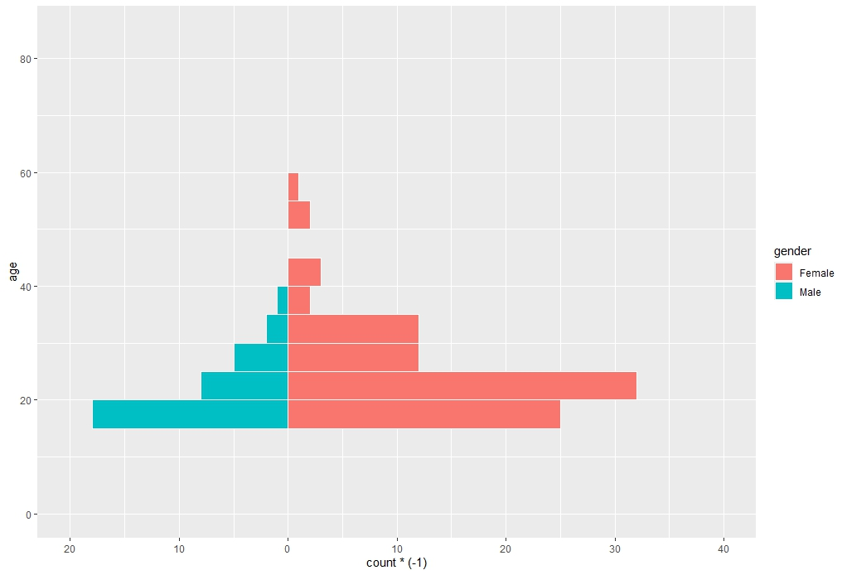

Figure 4.1a Age-sex pyramid of the participants in this study

Table 4.1.2 Clinical history of the participants

| **Characteristic** | **N = 123** |
| --- | --- |
| **Type of Sickle cell disease** |  |
| HbSC | 17 (14%) |
| HbSS | 106 (86%) |
| **Knowledge of steady PCV (Yes)** | 39 (34%) |
| **Medan PCV (IQR)** | 26.0 (22.5, 28.0) |
| **Last time PCV was checked** |  |
| <1 year ago | 3 (5.1%) |
| >5 years ago | 3 (5.1%) |
| 1-2 years ago | 51 (86%) |
| 2-5 years ago | 2 (3.4%) |
| Unknown | 64 |
| **Median value of last PCV (IQR)** | 24.0 (20.0, 28.0) |
| Unknown | 69 |
| **Number of crisis in past 6 months** |  |
| 1 | 83 (67%) |
| 2 | 40 (33%) |
| **Do you know the type of crises (Yes)** | 56 (46%) |
| **Specify the crises** |  |
| Bloodly urine | 2 (3.6%) |
| Body aches and malaria | 1 (1.8%) |
| Body and chest | 2 (3.6%) |
| Body pain | 16 (29%) |
| Chest pain | 1 (1.8%) |
| Haemolytic | 2 (3.6%) |
| Sickle cell crises of bone pain | 19 (34.1%) |
| Vasooccloive | 13 (23%) |
| Unknown | 67 |
| **Number of hospital admission** |  |
| 0 | 79 (64%) |
| 1 | 44 (36%) |
| **Number of blood transfusion** |  |
| 0 | 101 (82%) |
| 1 | 22 (18%) |
| **No of visits for chronic pain** |  |
| 0 | 66 (54%) |
| 1 | 57 (46%) |
| **Presence of complication (Yes)** | 51 (41.5%) |

Figure 4.1b Presence of complications among participants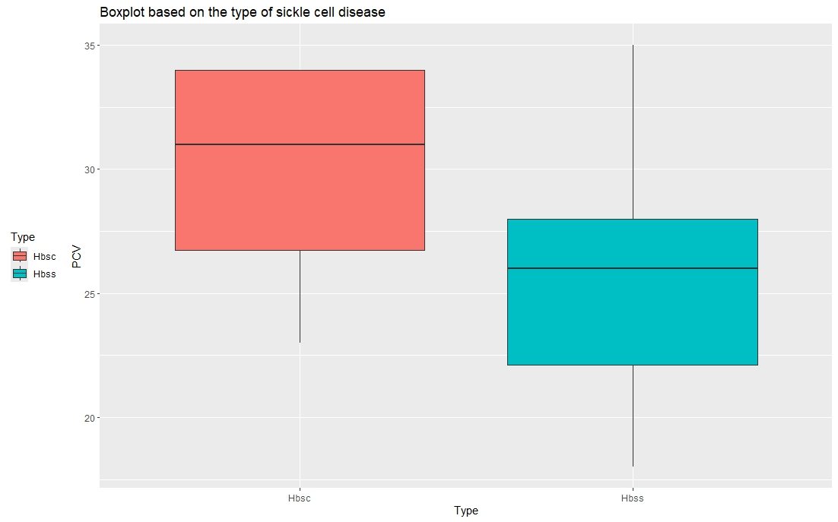

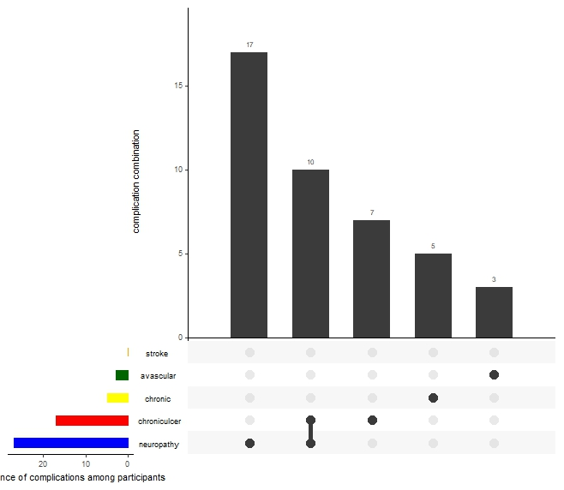

Figure 4.1c Boxplot showing PCV level among HbSC and HBSS

**4.2 Prevalence of Depression Among Participants**

The prevalence of depression was assessed using the PHQ-9 instrument. It was scored as follows: 0-5 (none-minimal), 5-9 (mild depression), 10-14 (moderate), 15-19 (moderately severe), 20-27 (severe). In this study, the prevalence of the depression is as follows: None (28.5%), Mild (30.9%), Moderate (26%), Moderately severe (9.8%) and Severe (4.9%). Figure 4.2b presents the distribution of sickle cell diseases according to the depression categories, it shows that the greatest proportion (50%) of HbSC participants had severe depression whereas, the greatest proportion (92.1%) of the HbSS participants had mild depression.

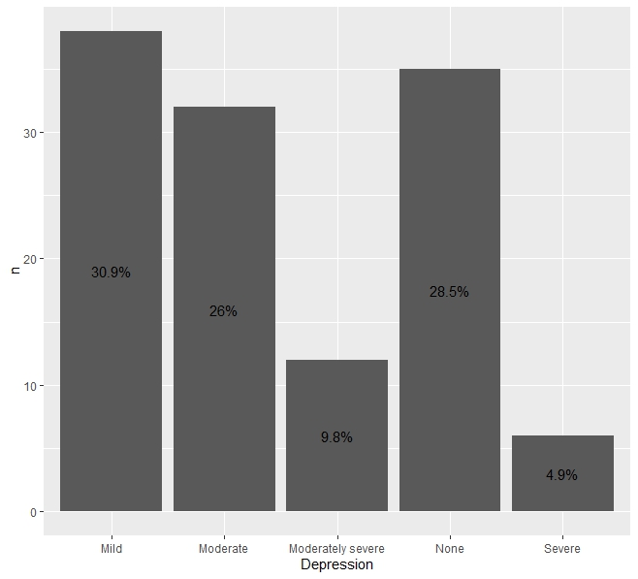

Figure 4.2a Prevalence of Depression in this study

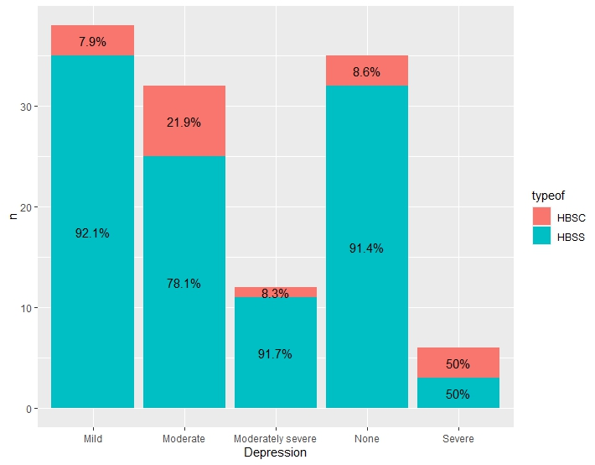

Figure 4.2b The distribution of sickle cell diseases according to the different depression categories.

**4.3 Health-related Quality of Life of the participants**

The health-related quality of life of the participants were assessed using the short-form 36. The 36-item questions were recoded as score as shown in Table 4.3.1, before regrouping them into 8 domains as follows: physical functioning PF, role functioning/physical RP, role functioning/emotional RE, energy/fatigue EF, emotional well-being EWB, social functioning SF, pain and general health GH. These 8 domains were categorized into physical health component (PCS) and mental health components (MCS). PCS comprises of PF, RP, PAIN and GF, while MCS comprises of RE, EF, EWB and SF.

The mean ± S.D of the 8 domains are as follows: PF (69.153 ± 24.458), RP (46.545±41.529), RE (52.575±45.570), EF (47.276±14.160), EWB (45.789±16.597), SF (44.512±20.254), pain (36.419±28.887) and GH (42.967±14.241). As for the components, both the physical (48.771±14.617) and mental (47.538±13.525) components recorded mean ± SD score within 40-60 which might suggest below average to slightly above average quality of life, where average quality of life is 50.

The Shapiro-Wilk test shows that both MCS and PCS were not in the normal distribution at p-value of 0.045 and 0.004 respectively. The implication of this is that non-parametric equivalents will be used when performing inferential test on the two parameters.

Table 4.3.1 SF-36 Recoding and scoring table

|  |  |
| --- | --- |
| Question number | Original response→ recoded value |
| 1, 2, 20, 22, 34, 36 | 1 → 100  2 → 75  3 → 50  4 → 25  5 → 0 |
| 3, 4, 5, 6, 7, 8, 9, 10, 11, 12 | 1 → 0  2 → 50  3 → 100 |
| 13, 14, 15, 16, 17, 18, 19 | 1 → 100  2 → 80  3 → 60  4 → 40  5 → 20  6 → 0 |
| 24, 25, 28, 29, 31 | 1 → 0  2 → 20  3 → 40  4 → 60  5 → 80  6 → 100 |
| 32, 33, 35 | 1 → 0  2 → 25  3 → 50  4 → 75  5 → 100 |

Table 4.3.2 Descriptive statistics of the domains and components of the Short form-36

| variable | n | min | max | median | IQR | mean | s.d | s.e |
| --- | --- | --- | --- | --- | --- | --- | --- | --- |
| PF | 123 | 0.000 | 100.00 | 75.000 | 35.000 | 69.153 | 24.458 | 2.205 |
| RP | 123 | 0.000 | 100.00 | 25.000 | 100.000 | 46.545 | 41.529 | 3.745 |
| RE | 123 | 0.000 | 100.00 | 66.667 | 100.000 | 52.575 | 45.570 | 4.109 |
| EF | 123 | 10.000 | 100.00 | 50.000 | 15.000 | 47.276 | 14.160 | 1.277 |
| EWB | 123 | 0.000 | 100.00 | 48.000 | 24.000 | 45.789 | 16.597 | 1.497 |
| SF | 123 | 0.000 | 100.00 | 50.000 | 12.500 | 44.512 | 20.254 | 1.826 |
| PAIN | 123 | 10.000 | 100.00 | 32.500 | 54.750 | 36.419 | 28.887 | 2.605 |
| GH | 123 | 10.000 | 75.00 | 45.000 | 15.000 | 42.967 | 14.241 | 1.284 |
| PCS | 123 | 18.250 | 86.25 | 50.625 | 18.188 | 48.771 | 14.617 | 1.318 |
| MCS | 123 | 13.125 | 75.00 | 47.750 | 21.750 | 47.538 | 13.525 | 1.220 |

n = number of samples, IQR = Interquartile range, s.d = standard deviation, s.e = standard error

Table 4.3.3 Shapiro-Wilk Normality test of the physical and mental components

| variable | statistic | p-value |
| --- | --- | --- |
| MCS | 0.9783708 | 0.045393977 |
| PCS | 0.9665474 | 0.003797518 |

**4.4.1 Predictors of Health Related Quality of Life HR-QOL (Physical components)**

This study employed the use of the chi-square test of association to determine the significant associations between variables and the quality of life at significant p-value of 0.05. As for the physical components, gender (chi-square = 3.584, p-value =0.045), type of sickle cell disease (chi-square = 4.044, p-value = 0.044) and number of blood transfusion episode <1yr (chi-square = 4.597, p-value = 0.032) were statistically significant associated with quality of life. For mental health components, education level (chi-square = 7.441 p-value = 0.024) and number of blood transfusion episode <1yr (chi-square = 3.880, p-value = 0.042) were statistically significant associated with quality of life.

Multinomial logistic regression was used to examine the predictors of below average HR-QOL, while taking significant level at p-value < 0.05. The male gender ([OR] = 2.168, p-value = 0.061, [AOR] = 2.164, p-value = 0.071) was 2.2 times more likely to have below average physical HR-QOL than the female gender. The HbSS participants ([OR] = 0.332, p-value = 0.042, [AOR] = 0.337, p-value = 0.050) were 0.33 times less likely to have below average physical HR-QOL than the HbSC. Participants who had 0 number of blood transfusion episode (OR] = 2.944, p-value = 0.037, [AOR] = 2.790, p-value = 0.048) were 2.8 times more likely to have below average physical HR-QOL than those that had one transfusion episode.

As for the predictors of below average mental HR-QOL, secondary level of education ([OR] = 3.960, p-value = 0.012, [AOR] = 4.425, p-value = 0.007) were 4.4 times significantly likely to have below average mental HR-QOL. Meanwhile, participants who had 0 number of blood transfusion episode (OR] = 2.561, p-value = 0.054, [AOR] = 2.226, p-value = 0.168) were 2.2 times more likely to have below average mental HR-QOL than those that had one transfusion episode.

Table 4.4.1 Predictors of Health Related Quality of Life (Physical components)

| Sociodemographic Characteristic | Below Average | Above Average | Chi-square | P-value |
| --- | --- | --- | --- | --- |
| **Age category** |  |  | 3.910 | 0.428 |
| 10-19years | 15 (45.5%) | 18 (54.5%) |  |  |
| 20-29years | 33 (53.2%) | 29 (46.8%) |  |  |
| 30-39years | 7 (31.8%) | 15 (68.2) |  |  |
| 50-59years | 2 (66.7%) | 1 (33.3%) |  |  |
| **Gender** |  |  | 3.584 | 0.045&* |
| Female | 38 (42.7%) | 51 (57.3%) |  |  |
| Male | 21 (61.8%) | 13 (38.2%) |  |  |
| **Ethnicity** |  |  |  |  |
| Ibo | 8 (57.1%) | 6 (42.9%) | 0.630 | 0.730 |
| Others | 2 (40.0%) | 3 (60.0%) |  |  |
| Yoruba | 49 (47.1%) | 55 (52.9%) |  |  |
| **Marital status** |  |  | 1.637 | 0.441 |
| Married | 6 (50%) | 6 (50%) |  |  |
| Separated | 1 (20%) | 4 (80%) |  |  |
| Single | 52 (49.1%) | 54 (50.9%) |  |  |
| **Religion** |  |  | 0.479 | 0.489 |
| Christianity | 35 (50.7%) | 34 (49.3%) |  |  |
| Islam | 24 (44.4%) | 30 (55.6%) |  |  |
| **Education level** |  |  | 5.280 | 0.071 |
| Primary | 3 (42.9%) | 4 (57.1%) |  |  |
| Secondary | 49 (59.8%) | 33 (40.2%) |  |  |
| Tertiary | 6 (31.6%) | 13 (68.4%) |  |  |
| **Source of healthcare financing** |  |  | 0.277 | 0.599 |
| HMO | 4 (40%) | 6 (60%) |  |  |
| Self | 55 (48.7%) | 58 (51.3%) |  |  |
| **Type of Sickle cell disease** |  |  | 4.044 | 0.044* |
| HbSC | 12 (70.6%) | 5 (29.4%) |  |  |
| HbSS | 47 (44.3%) | 59 (55.7%) |  |  |
| **Number of hospital admission** |  |  | 0.629 | 0.428 |
| 0 | 40 (50.6%) | 39 (49.4%) |  |  |
| 1 | 19 (43.2%) | 25 (56.8%) |  |  |
| **Number of blood transfusion episode in the past 1 year** |  |  | 4.597 | 0.032* |
| 0 | 53 (52.5%) | 48 (47.5%) |  |  |
| 1 | 6 (27.3%) | 16 (72.7%) |  |  |
| **No of visits for chronic pain** |  |  | 0.718 | 0.397 |
| 0 | 34 (51.5%) | 32 (48.5%) |  |  |
| 1 | 25 (43.9%) | 32 (56.1%) |  |  |
| **Presence of comorbidities** |  |  | 0.287 | 0.592 |
| No | 36 (50%) | 36 (50%) |  |  |
| Yes | 23 (45.1%) | 28 (54.9%) |  |  |

& - fisher exact, *- significant at p<0.05

Table 4.4.2 Multivariate analysis of the predictors of health related quality of life (Physical components below average)

| Variables | Odd Ratio | P-value | 95% CI | Adj. Odd ratio | | p-value | 95%CI |
| --- | --- | --- | --- | --- | --- | --- | --- |
| **Gender** |  |  |  |  | |  |  |
| Male | 2.168 | 0.061 | 0.965-4.870 | 2.164 | | 0.071 | 0.936-5.002 |
| Female | 1 (ref) |  |  | 1 (ref) | |  |  |
| **Type of SCD** |  |  |  |  | |  |  |
| HbSS | 0.332 | 0.042* | 0.109-1.009 | 0.337 | | 0.050 | 0.107-1.063 |
| HbSC | 1 (ref) |  |  | 1 (ref) | |  |  |
| **Number of blood transfusion episode in the past 1 year** |  |  |  |  | |  |  |
| 0 | 2.944 | 0.037* | 1.066-8.135 | 2.790 | | 0.048 | 0.988-7.873 |
| 1 | 1 (ref) |  |  | 1 (ref) |  | | | |  |

*- significant at p<0.05

Table 4.4.1 Predictors of Health Related Quality of Life (Mental components)

| Sociodemographic Characteristic | Below Average | Above Average | Chi-square | P-value |
| --- | --- | --- | --- | --- |
| **Age category** |  |  | 6.680 | 0.154 |
| 10-19years | 19 (57.6%) | 14 (42.4%) |  |  |
| 20-29years | 38 (61.3%) | 24 (38.7%) |  |  |
| 30-39years | 9 (40.9%) | 13 (59.1) |  |  |
| 50-59years | 2 (66.7%) | 1 (33.3%) |  |  |
| **Gender** |  |  | 1.687 | 0.194 |
| Female | 46 (51.7%) | 43 (48.3%) |  |  |
| Male | 22 (64.7%) | 12 (35.3%) |  |  |
| **Ethnicity** |  |  |  |  |
| Ibo | 7 (50%) | 7 (50%) | 0.213 | 0.899 |
| Others | 3 (60.0%) | 2 (40.0%) |  |  |
| Yoruba | 58 (55.8%) | 46 (44.2%) |  |  |
| **Marital status** |  |  | 1.592 | 0.451 |
| Married | 5 (57.5%) | 7 (58.3%) |  |  |
| Separated | 2 (40%) | 3 (60%) |  |  |
| Single | 61 (57.5%) | 45 (42.5%) |  |  |
| **Religion** |  |  | 1.322 | 0.250 |
| Christianity | 35 (50.7%) | 34 (49.3%) |  |  |
| Islam | 33 (61.1%) | 21 (38.9%) |  |  |
| **Education level** |  |  | 7.441 | 0.024* |
| Primary | 5 (71.4%) | 2 (28.6%) |  |  |
| Secondary | 53 (64.6%) | 29 (35.4%) |  |  |
| Tertiary | 6 (31.6%) | 13 (68.4%) |  |  |
| **Source of healthcare financing** |  |  | 1.029 | 0.310 |
| HMO | 4 (40%) | 6 (60%) |  |  |
| Self | 64 (56.6%) | 49 (43.4%) |  |  |
| **Type of Sickle cell disease** |  |  | 0.100 | 0.752 |
| HbSC | 10 (58.8%) | 7 (41.2%) |  |  |
| HbSS | 58 (54.7%) | 48 (45.3%) |  |  |
| **Number of hospital admission** |  |  | 2.678 | 0.102 |
| 0 | 48 (60.8%) | 31 (39.2%) |  |  |
| 1 | 20 (45.5%) | 24 (54.5%) |  |  |
| **Number of blood transfusion episode in the past 1 year** |  |  | 3.880 | 0.042* |
| 0 | 60 (59.4%) | 41 (40.6%) |  |  |
| 1 | 8 (36.4%) | 14 (63.6%) |  |  |
| **No of visits for chronic pain** |  |  | 2.693 | 0.101 |
| 0 | 41 (62.1%) | 25 (37.9%) |  |  |
| 1 | 27 (47.4%) | 30 (52.6%) |  |  |
| **Presence of comorbidities** |  |  | 0.653 | 0.419 |
| No | 42 (58.3%) | 30 (41.7%) |  |  |
| Yes | 26 (51%) | 25 (49%) |  |  |

*- significant at p<0.05

Table 4.4.2 Multivariate analysis of the predictors of health related quality of life (mental components below average)

| Variables | Odd Ratio | P-value | 95% CI | Adj. Odd ratio | | p-value | 95%CI |
| --- | --- | --- | --- | --- | --- | --- | --- |
| **Education** |  |  |  |  | |  |  |
| Primary | 5.417 | 0.082 | 0.807-36.356 | 5.228 | | 0.089 | 0.778-35.14 |
| Secondary | 3.960 | 0.012* | 1.361-11.521 | 4.425 | | 0.007* | 1.492-13.11 |
| Tertiary | 1 (ref) |  |  | 1 (ref) | |  |  |
| **Number of blood transfusion episode in the past 1 year** |  |  |  |  | |  |  |
| 0 | 2.561 | 0.054 | 0.985-6.656 | 2.226 | | 0.168 | 0.714-6.940 |
| 1 | 1 (ref) |  |  | 1 (ref) |  | | | |  |

*- significant at p<0.05

**4.5 The relationship between health-related QOL and depression**

The highest score of the physical health component were seen among the participants who were not depressed, the median (55.625) is suggestive of an above average quality of life, while, the lowest scores were seen among participants with severe form of depression, the median (43.438) is suggestive of a below average quality of life among this category of participants.

The highest score of the mental health component was seen among the non-depressed participants, the median (52.042) indicates an above average quality of life, while, the lowest score was seen among participants with moderately severe form of depression, the median (43.438) is suggestive of a below average quality of life among this category of participants.

The Kruskal-Wallis rank sum test was used to determine the statistical difference within the depression category and the components of health-related quality of life, while, taking significance at p-value < 0.05. It was revealed that there was no statistical difference within the depression category as regard their mental health component score (p-value = 0.7), likewise, there was no statistical significant difference within the depression category as regards their physical health component score (0.2), see table 4.5.2.

The Chi-square test of association was used to determine any statistically significant association between depression and health related quality of life, at p-value < 0.5. There was no significant association between depression and the health related quality of life components: physical health component (chi-square =4.434 p-value = 0.350), mental health components (chi-square =6.702, p-value = 0.152)

Table 4.5.1 summary statistics of the SF-36 component within the depression categories

| Depression | variable | n | min | max | median | IQR | mean | s.d | s.e |
| --- | --- | --- | --- | --- | --- | --- | --- | --- | --- |
| Mild | MCS | 38 | 22.000 | 71.667 | 48.375 | 18.500 | 48.371 | 12.594 | 2.043 |
| Mild | PCS | 38 | 20.750 | 85.000 | 48.438 | 12.562 | 49.788 | 12.952 | 2.101 |
| Moderate | MCS | 32 | 22.292 | 70.625 | 44.479 | 22.812 | 44.828 | 13.879 | 2.453 |
| Moderate | PCS | 32 | 18.250 | 86.250 | 50.938 | 20.531 | 46.918 | 16.231 | 2.869 |
| Moderately severe | MCS | 12 | 30.875 | 64.250 | 43.188 | 18.500 | 46.587 | 12.241 | 3.534 |
| Moderately severe | PCS | 12 | 20.750 | 75.625 | 50.625 | 21.906 | 49.135 | 18.202 | 5.254 |
| None | MCS | 35 | 13.125 | 75.000 | 52.042 | 22.625 | 49.317 | 15.370 | 2.598 |
| None | PCS | 35 | 18.250 | 69.375 | 55.625 | 19.125 | 50.629 | 14.280 | 2.414 |
| Severe | MCS | 6 | 37.000 | 62.500 | 46.833 | 9.406 | 48.243 | 9.081 | 3.707 |
| Severe | PCS | 6 | 29.375 | 53.250 | 43.438 | 11.875 | 40.646 | 9.462 | 3.863 |

n = number of samples, IQR = Interquartile range, s.d = standard deviation, s.e = standard error

Table 4.5.2: The relationship between health-related QOL and depression

| Characteristic | *1*Mild  N = 38 | *1*Moderate  N = 32 | *1*Moderately severe  N = 12 | *1*None  N = 35 | *1*Severe  N = 6 | *2*p-value |
| --- | --- | --- | --- | --- | --- | --- |
| MCS | 48 (40, 59) | 44 (33, 57) | 43 (37, 59) | 52 (36, 60) | 47 (42, 54) | 0.7 |
| PCS | 48 (46, 58) | 51 (36, 57) | 51 (36, 61) | 56 (37, 61) | 43 (29, 45) | 0.2 |

*1*

Median (IQR)

*2*

Kruskal-Wallis rank sum test

Table 4.5.3 Association between health related quality of life and depression

| Variable | Below Average | Above Average | Chi-square | P-value |
| --- | --- | --- | --- | --- |
| *Physical health components* |  |  |  |  |
| **Depression** |  |  | 4.434 | 0.350 |
| None | 14 (40%) | 21 (60%) |  |  |
| Mild | 20 (52.6%) | 18 (47.4%) |  |  |
| Moderate | 15 (46.9%) | 17 (53.1%) |  |  |
| Moderately severe | 5 (41.7%) | 7 (58.3%) |  |  |
| Severe | 5 (83.3%) | 1 (16.7%) |  |  |
| *Mental health components* |  |  |  |  |
| **Depression** |  |  | 6.706 | 0.152 |
| None | 14 (40%) | 21 (60%) |  |  |
| Mild | 20 (52.6%) | 18 (47.4%) |  |  |
| Moderate | 22 (68.8%) | 10 (31.2%) |  |  |
| Moderately severe | 8 (66.7%) | 4 (33.3%) |  |  |
| Severe | 4 (66.7%) | 2 (33.3%) |  |  |

**4.6 Hypothesis testing**

The hypothesis of this study were stated as follows:

* H0: There is no statistically significant relationship between the health-related quality of life and depression amongst sickle cell disease patients.
* H1: There is a statistically significant relationship between health-related quality of life and depression amongst sickle cell disease patients.

By using the Kruskal-Wallis sum rank test and the Chi-square test of association, this study has shown that there was statistically significant relationship between the health related quality of life and depression. Hence, we fail to reject the null hypothesis which states that there is no statistically significant relationship between the health related quality of life and depression, H0: µ1 = µ2